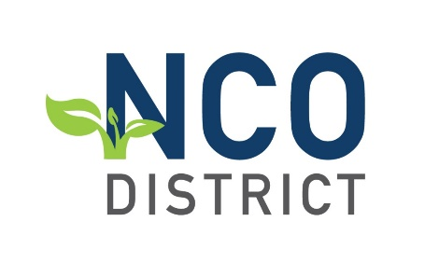
Church/Ministry Name:________________________________________ Year:______________
Accountable Person: ____________________________________
Ministry Grant Dollar Requested __________________ (Maximum is $2,000)
__________________________________________________________________________________________________
Please note: The number of grants given each year are dependent upon the annual budget established for that particular Assembly Year. Applications for the 21-22 budget year will be due by August 1. As a Finance Team, we will make a recommendation for funding to the DAB at their August planning session.
What is the grant for?
The grant is to be used for evangelistic efforts to help your congregation share the love of Jesus with your community. The grant can be used for supplies, advertising, point of need items, and more. (We want you to be creative!) Your plan should include both the event as well as intentional follow up plans. We ask that 66% of the plan go toward the “reach” with the remaining 34% to go toward “relationships”.
How does your church apply?
Send your outreach plan (this document) to nco.district@mvnu.edu. The deadline for submitting your plan is August 1 of each Assembly year. Funds must be used for the assembly year in which you are applying. Feel free to use extra paper if necessary and answer all that apply. If something doesn’t fit your context, please document why it does not.
What will the grant be used for?
What is the expected outcome of the use of these funds? (Changed lives, new attendees, community connections, etc.)
How do you plan to follow up?

If awarded, you will be asked to provide a report answering the following questions:
What were the results of the ministry/evangelistic event?
How many lives were impacted?
How has follow up happened?
Any personal story of transformation you could share?
Provide financial records showing how the dollars were spent. (Remember: 66% for “reach” and 34% for “relationship”)
The financial report needs to be in printed form. The balance of the report can be provided in print form or in short video form showing the ministry that was conducted with the funds. This video does not have to be professionally done. The quality you would get from a smartphone would be sufficient. (At minimum please ensure that photos are taken of the event to share with the district.) Please email all report information to: nco.district@mvnu.edu
By requesting these funds you agree to report back to the district no longer than 45 days after the ministry has been completed.

