presents

Baseball Legend Darryl Strawberry
Wednesday, July 11, 7:30pm
Mount Vernon Nazarene University Chapel Auditorium
800 Martinsburg Road, Mount Vernon, OH 43050

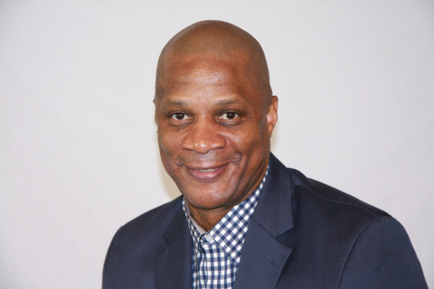
Darryl Strawberry is slated as the opening speaker for North Central Ohio District Church of the Nazarene Family Camp on Wednesday, July 11, 2018, at 7:30pm in the Mount Vernon Nazarene University Chapel Auditorium.
Darryl Strawberry, an admitted drug abuser and alcoholic, former Rookie of the Year and four-time World Series champion will share his incredible testimony of healing through a relationship with Christ.
Strawberry, whose MLB career spanned 17 seasons, immediately rose to fame as a baseball star with the New York Mets in 1983. For nearly two decades, Strawberry experienced an abundance of on-field success. However, that success did not translate off the field. Strawberry became addicted to substances, found himself in legal trouble and several marriages ended in divorce. He’s been to jail, drug treatment centers and hospitals, and was $3 million in debt.
All of Strawberry’s attempts to get back on track, failed because he was trying to do it alone, he said. Once he accepted God into his life, he saw things more clearly. “There were many times when I tried to get myself together but I couldn’t,” said Strawberry. “God never shows us anything different, God is going to use people to help people.”
Strawberry is using his testimony to inspire others to accept God into their lives. “My message is God must increase while I must decrease,” said Strawberry. “If I need to get somewhere in life, I must decrease, and let him lead my life or I can never fulfill the promises.”
Nursery and activities for children through grade 6 will be offered on-site during the event. Family Camp activities will continue through Sunday, July 15. A full schedule of events can be found online at ncodistrict.org. North Central Ohio District Church of the Nazarene represents over 60 Nazarene churches from Powell, Ohio, to Lake Erie. The NCO District exists to make disciples of Jesus Christ by: Resourcing our Pastors to fulfill the Great Commission; Empowering our Churches for Cultural Engagement; and Inspiring our People for Missional Living.

