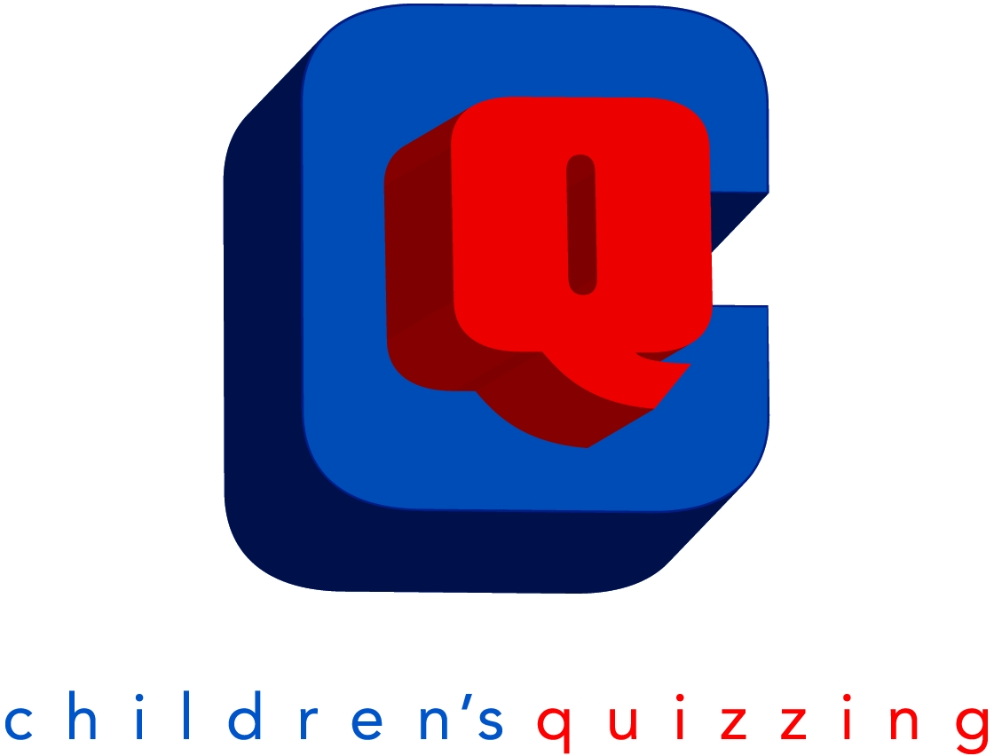
CHILDREN’S BIBLE QUIZZING

NORTH CENTRAL OHIO DISTRICT

Nicole Diller, NCO Children’s Bible Quiz Co- Director
E-mail: nickydiller@gmail.com
419-563-9609

Mary Eames, NCO Children’s Bible Quiz Co-Director
E-mail: mary.boosz@gmail.com

Welcome to Children’s Bible Quizzing!

It’s hard to believe it is that time again! Summer is in full swing and flying by at lightning speed, and that means fall is close behind, and it is time to dig into God’s Word and enjoy Children’s Bible Quizzing. Our district is very large and covers a lot of distance. Therefore, it has been broken down into 4 zoned divisions: Central, North, North-East, and South.

Each area will host a quiz meet in September, November, January, and February. There will be a district quiz in March followed by the Regional Quiz at MVNU in May. Once details are received, we will communicate accordingly for Regional Quiz.

Cost per quizzer for each zone is $2.00 at each meet including the district qualifier. The cost & date for the regional is yet to be determined. We will continue to have rainbow, red, and blue level quizzes at the same time.

Each Zone leader has the authority to move quiz dates for the three invitationals and qualifier to either Saturday morning or Sunday afternoon, based on each zone’s availability. Recommendations for timing: Registration needs to begin at least a half hour before the start of a quiz at each location. If needed for any specific reason coaches and scorekeepers meeting should be held at least 15 minutes before the quiz starts.

The quiz needs to begin on time based on the time set by the zone leader. Rainbow quizzers can quiz at the September, November, January and February quiz, but they will not quiz at the District quiz in March unless they want to try and quiz as a Red level Quizzer at the District Qualifier and District Quiz.

There will be two rounds of quizzing for all levels.
Rainbow Level will consist of the following:
*10 questions per round
*2 answers to choose from
*Unable to qualify for the District quiz; and unable to qualify for the World quiz because this is only offered in our district unless they quiz as Red Level in the qualifier and district quiz.

Red Level will consist of the following:
*15 questions per round
*Each round will contain WORD for WORD questions directly from the leader/pupil book
*Each round will include some REWORDED questions from the leader/pupil book
*Memory work questions

Blue Level will consist of the following:
*20 questions per round
*Each round will contain WORD for WORD questions directly from the leader/pupil book
*Each round will include some REWORDED questions from the leader/pupil book
*Memory work questions

We will also be sending a specific scripture verse to be quoted word for word as an added bonus at the end of each round for Red & Blue Level quizzes only. We will handle this portion of the quiz as follows at the local zone meets: When the round is complete at red and blue level the students will be asked to quote a specific scripture verse. Students will be allowed to come up and quote the memory verse to the quiz master and will receive a small prize/piece of candy if they are able to quote the verse word for word. Memory work is taken from the quiz books and from the list of memory verses students are studying.
Memory work CD’s are now available at www.hideandkeep.com.

Scoring and reward levels are as follows:
*Bronze Award= 70-79% correct
*Silver Award= 80-89% correct
*Gold Award= 90-99% correct
*Gold All Star= 100% correct
Purple Ribbons = Perfect round, can earn up to 2 per meet

Each church needs to provide one adult scorekeeper for every five quizzers. All scorekeepers MUST be an ADULT. Please have others that are willing to score keep, this helps keep things moving.

Ribbons will be awarded at zone quiz meets and medallions will be awarded at the district quiz. Each participant that receives a Gold-All Star at district quiz also receives a discount coupon to attend children’s camp in the summer.

Challenges are only allowed for the accuracy of the question and answer according to scripture.

The last scheduled zone quiz meet is taking place on Saturday or Sunday; and we will meet together as a district for the District Finals on a Saturday this season. I know this presents some late nights for our outlying churches. It is an awesome experience gathering together as a district for the District Finals. I encourage each church to make children’s quizzing a priority in your ministry program of teaching and learning about Christ.

Additional ideas for practice or people studying at home. Canton Nazarene posts YouTube videos of each dig site, they are very well put together; here is the link: https://www.youtube.com/playlist?list=PLpvyZa0QkYvKd9hoCKZxlhrczUSXPewI-

Blessings,
Nicole Diller & Mary Eames

Children’s Bible Quizzing Schedule 2024-25
Book of Acts
Rainbow, Red, and Blue Level

1st INVITATIONAL – September 28th or 29th, 2024
Location: Each Zone and Church may be different, Zone leaders will be contacting coaches for more details
Lessons 1-5: 2-3 memory work questions

2nd INVITATIONAL – November 9th or 10th, 2024
Location: Each Zone and Church may be different, Zone leaders will be contacting coaches for more details
Lessons 1-10: 4-5 memory work questions

3rd INVITATIONAL – January 11th or 12th, 2025
Location: Each Zone and Church may be different, Zone leaders will be contacting coaches for more details
Lessons 1-15: 4-5 memory work questions

DISTRICT QUALIFIER – February 22nd or 23rd, 2025
Location: Each Zone and Church may be different, Zone leaders will be contacting coaches for more details
Lessons 1-20: 4-5 Memory Work Questions
- Those who earn a 50% or better move on to District Quiz

DISTRICT QUIZ FINALS – Saturday , March 29th, 2025
Location: Bucyrus First Church of the Nazarene
(2165 St. Rt. 4, Bucyrus, OH 44820) - All Zones report to this location
Registration will open at 3:30pm. Quiz Begins at 4:00pm.
Lessons 1-20: Memory Work Questions
- District quiz needs 80% or better to go on to Regionals.

REGIONAL QUIZ - Date to be Confirmed, 2025
Location: Mount Vernon University, Ariel Arena at 800 Martinsburg Rd.,
Mount Vernon, OH, 43050
Cost to be determined.

