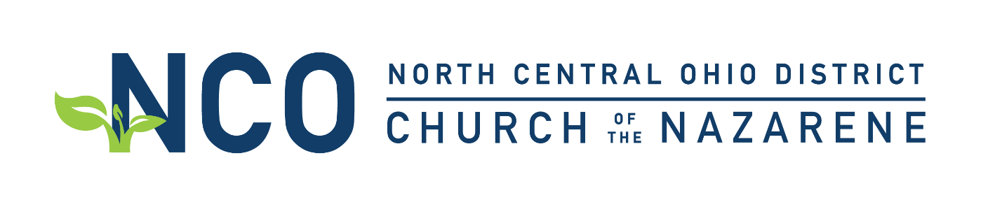
2021-2022
Departmental Finance Best Practices
The district is your partner and wishes to assist you in sharing the gospel with the people in your area of ministry. As a result, we wish to enact the following best practices for departmental funding to ensure we can provide the needed resources to you in a timely fashion.
1. Reimbursement
-All reimbursements must be requested within 30 days of expenditure.
-An approved department reimbursement will include:
Documentation of Expense (When, Why) and where to apply the expense to the budget.
Receipt(s) of Expense (Actual receipt/credit card statements/written documentation)
Be within overall department budget
-Advance reimbursement is possible with documentation. (Trips/Hotels/Large Purchases) - 6 days are required for any advance reimbursement request.
2. Check Requests
-All Check Requests will be submitted through email to Patrick Rhoton (nco.treasurer@mvnu.edu) a minimum of 6 days before check is required. Please provide proper documentation. (When, Why)
-Please inform treasurer where in your budget the funds should be taken from.
-Additional funds for special events/trips outside of budget will be taken from other areas of your budget therefore reducing your overall budget amount until funds are deposited to account for any shortfall in expenditures.
3. Budget
-Oversight and management of your budget depends on your council.
-When district fair share funding has met the overall district budget at the end of the fiscal year, individual departments can request up to 50% of remaining funds from current year and apply them to the following year for special budget items or project expenses. This request will be considered by the finance team for approval based on the overall financial picture of the district.
-Please remember that department budgets are dependent on district receipt of Fair Share budgets.
*Note that it is not possible for additional money to be granted to your ministry outside of budget without DAB approval.
Oversight and management of your budget depends on your council and their input as well.
-Please remember that department budgets are dependent on district receipt of Fair Share budgets.
Please note that it is not possible for additional money to be granted to your ministry outside of budget without DAB approval.

4. Larger Purchases
We understand that sometimes there is the need for special events and trips to have a credit card for securing large items/purchases of block hotel rooms, etc. In those instances, the district will be happy to help by placing those purchases on the district credit card. Additionally, the district can provide a Prepaid Visa Card to be used in travel or large purchases to make the purchases easier to manage. Please contact the district office for those requests at least 6 days prior to need.

